

DATA WAREHOUSING AND DATA MINING

Submitted By

|  |  |
| --- | --- |
| 15-29499-2 | Sayem Mohammad Zishan |

Department of Computer Science

Faculty of Science & IT

American International University Bangladesh

**April, 2018**

Project 1: Car evaluation database

Attribute Values:

Buying: v-high, high, med, low

Maint: v-high, high, med, low

Doors: 2, 3, 4, 5-more

Persons: 2, 4, more

lug_boot: small, med, big

safety: low, med, high

Missing Attribute Values: none

Class Distribution (number of instances per class)

class N N[%]

-----------------------------

unacc 1210 (70.023 %)

acc 384 (22.222 %)

good 69 ( 3.993 %)

v-good 65 ( 3.762 %)

Problem: What kind of cars can get good evaluation? Here we will use some classifier for find out car evaluation.

Dataset prepare: There is no missing values so I just take data from given link and prepare as arff(attribute relation file format).

Naïve Bayes Classifier:

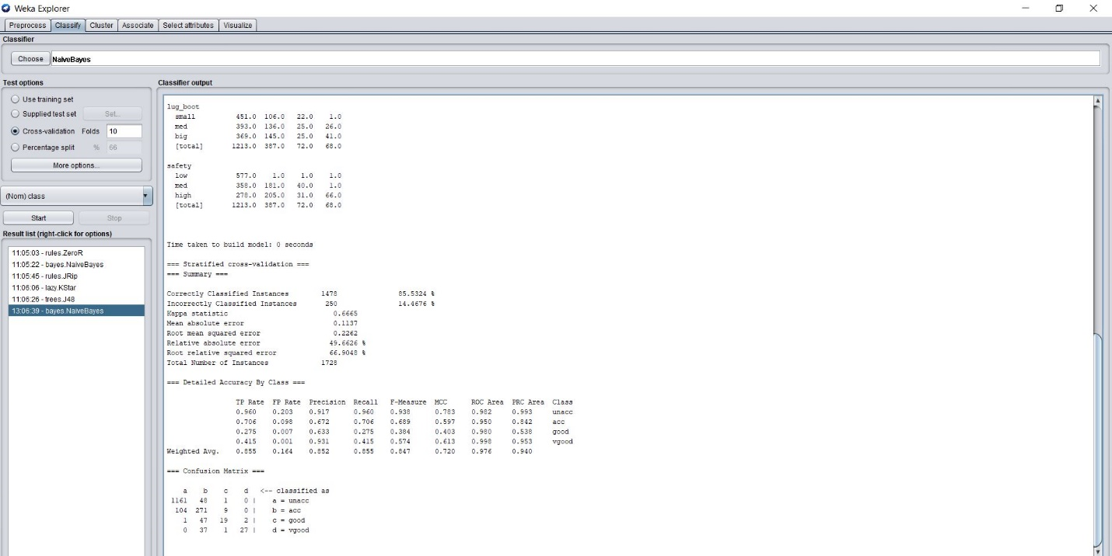

Here the weighted average of true positive and false positive are 0.855 and 0.164.

===Confusion Matrix===

a b c d <-- classified as

1161 48 1 0 | a = unacc

104 271 9 0 | b = acc

1 47 19 2 | c = good

0 37 1 27 | d = vgood

J48 Classifier:

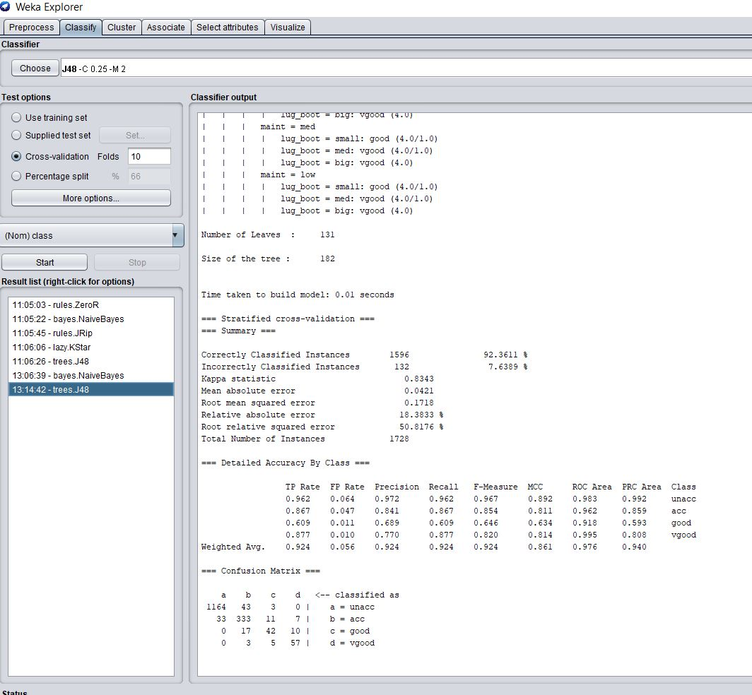

Here the weighted average of true positive and false positive are 0.924 and 0.056.

=== Confusion Matrix ==

a b c d <-- classified as

1164 43 3 0 | a = unacc

33 333 11 7 | b = acc

0 17 42 10 | c = good

0 3 5 57 | d = vgood

ZeroR Classifier :

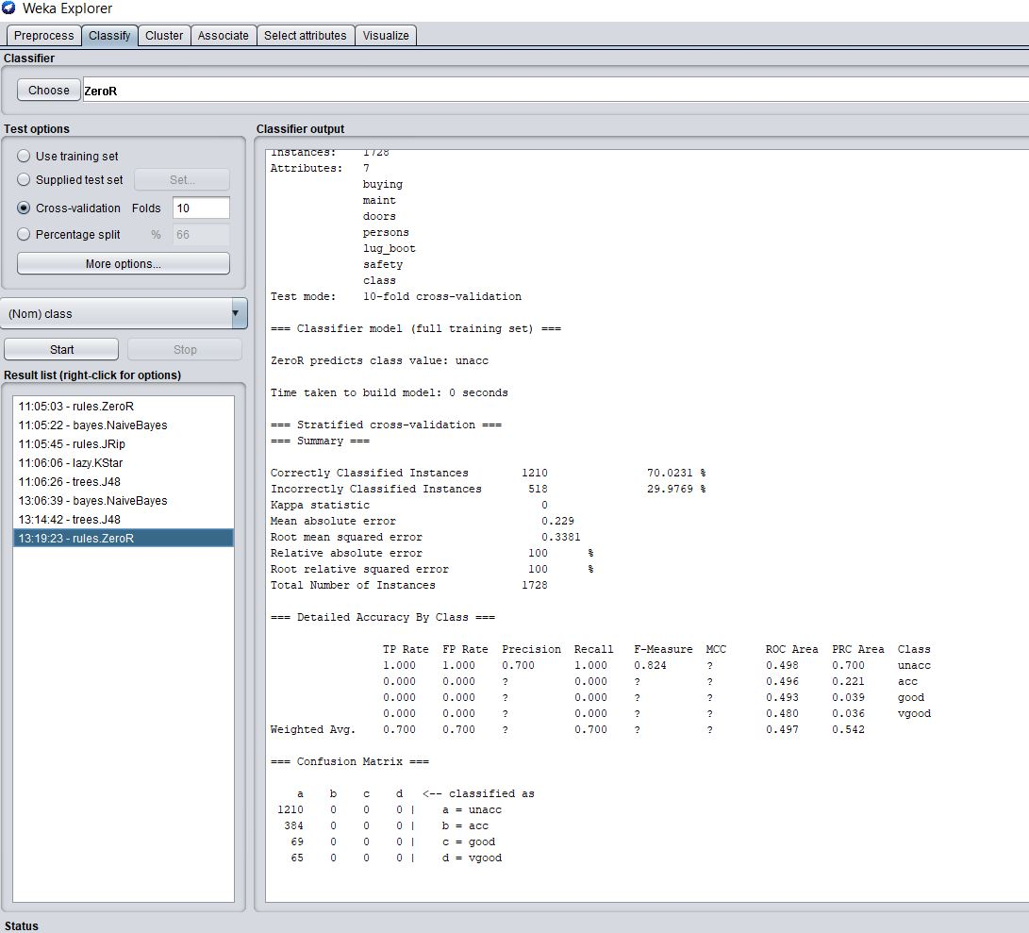

Here the weighted average of true positive and false positive are 0.7 and 0.7.

=== Confusion Matrix ===

a b c d <-- classified as

1210 0 0 0 | a = unacc

384 0 0 0 | b = acc

69 0 0 0 | c = good

65 0 0 0 | d = vgood

KStar:

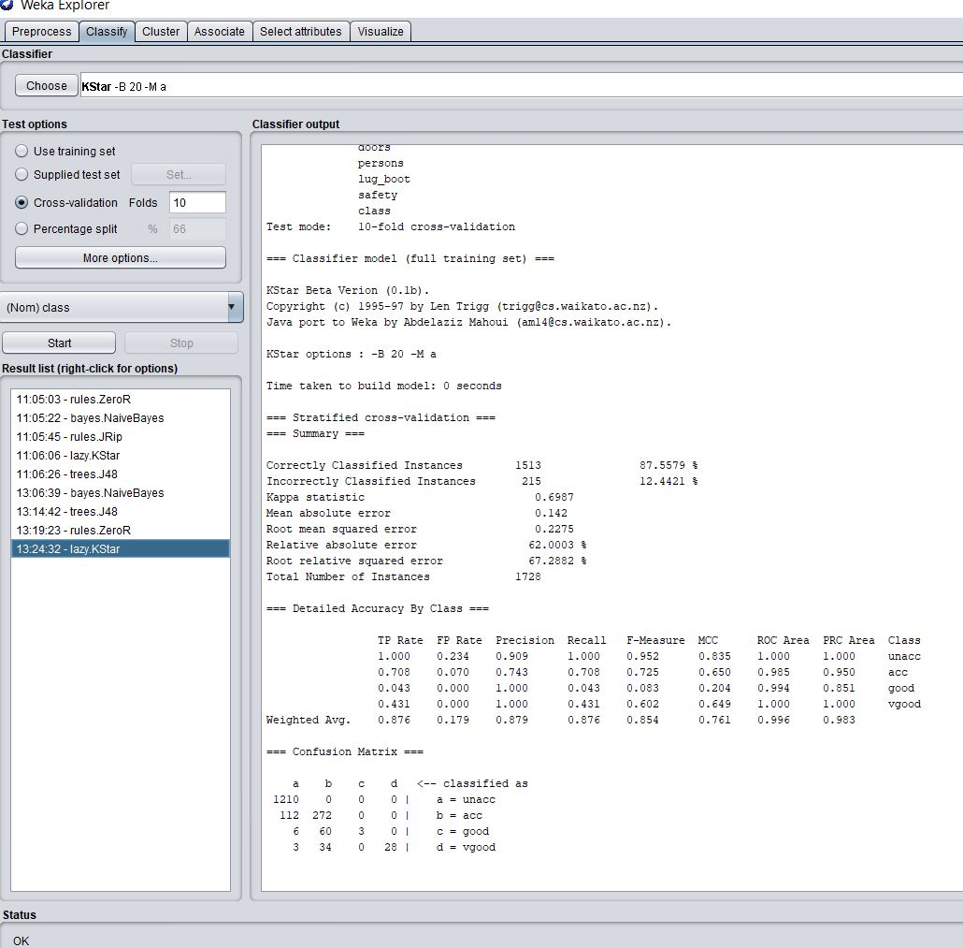

Here the weighted average of true positive and false positive are 0.876 and 0.179.

=== Confusion Matrix ===

a b c d <-- classified as

1210 0 0 0 | a = unacc

112 272 0 0 | b = acc

6 60 3 0 | c = good

3 34 0 28 | d = vgood

JRip Classifier :

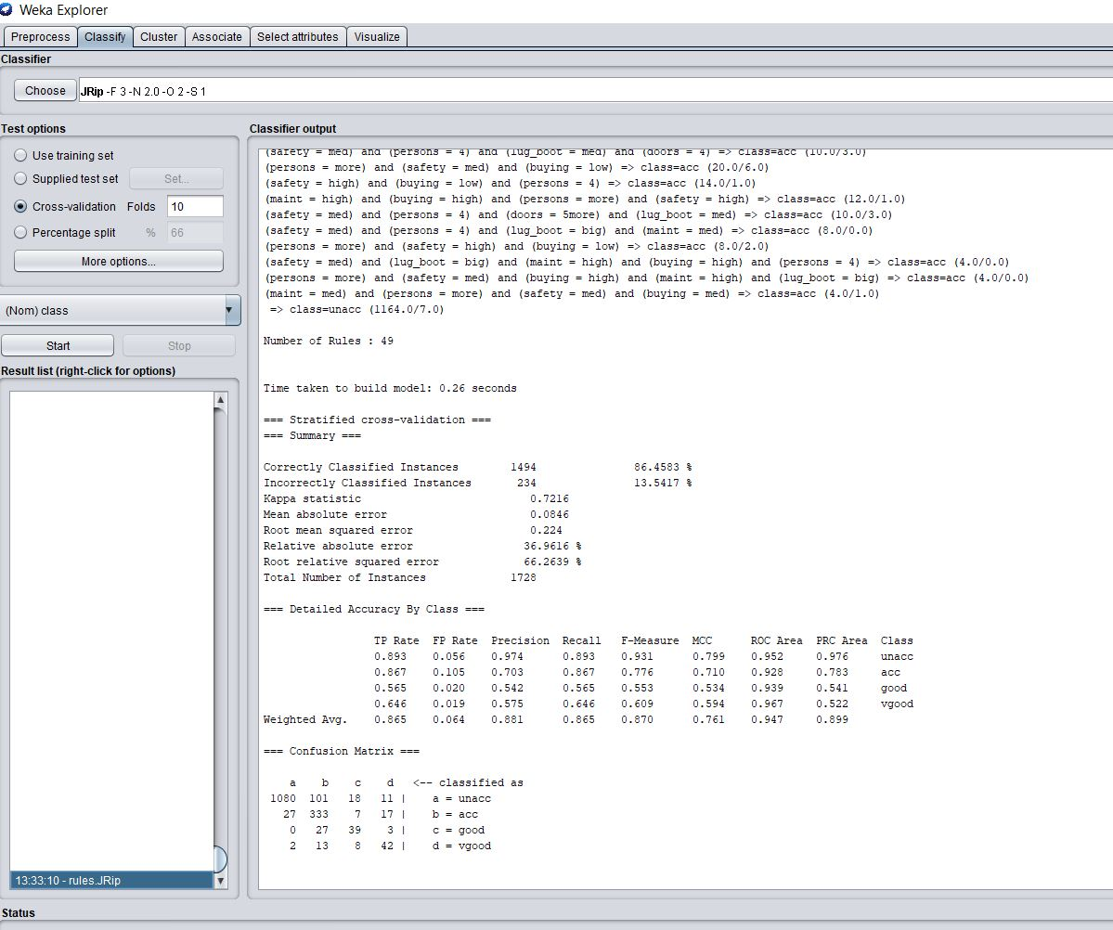

Here the weighted average of true positive and false positive are 0.865 and 0.064.

=== Confusion Matrix ===

a b c d <-- classified as

1080 101 18 11 | a = unacc

27 333 7 17 | b = acc

0 27 39 3 | c = good

2 13 8 42 | d = vgood

|  |  |  |
| --- | --- | --- |
| Classifiers | True positive Rate (TPR) | False Positive Rate (FPR) |
| Naïve bayes Classifier | 0.855 | 0.164 |
| J48 Classifier | 0.924 | 0.056 |
| ZeroR classifier | 0.7 | 0.7 |
| KStar Classifier | 0.876 | 0.179 |
| JRip Classifier | 0.865 | 0.064 |

ROC Graph:

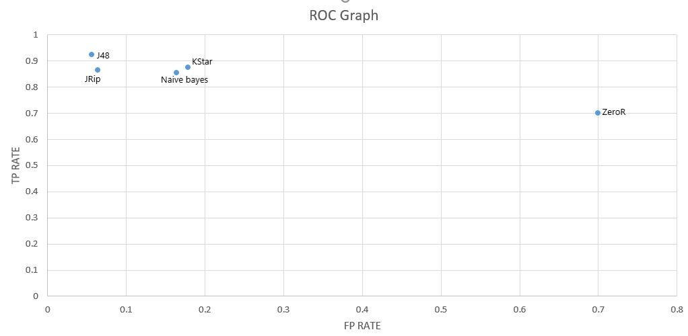

Comment:

We can see in the ROC graph that J48 is giving the best result for my interest. The FP rate is lower as it gave only 33 output as wrong out of 518 input and TP rate is also higher where only 46 output came as wrong out of 1210 input. Other classifiers are also giving near value but ZeroR gave worst result out of all the classifiers.

So for the prediction I choose J48 as the classifier.

Project 2:

**Hierarchical Clustering**

**Project Definition**

The purpose of this project is to find the most suitable cereal having the right ingredients from the cereal data set and find any possible co-relation between ingredients of cereals that may lead to a better knowledge for healthy breakfast.

**Literature Survey**

To prepare this report, we use a data mining tool on a pre-compiled dataset cereals. The name of the tool is ‘Weka’. There have been a vast concern is developing among individuals for a proper diet and a healthy life. So, this report will give a satisfactory result.

**Methods**

Step 1: I made a .arff file of the given data set and I open it on **WEKA**

Step 2: With the filter option, I added an id attribute to the data set for better consideration in the later steps.

Step 3: From the Cluster tab I have chosen hierarchical clustering and applied it on the data set using training set.

Step 4: Right click on the result list and go to the ‘visualize tree’ option

Step 5: Took a screenshot and with that applied the cutting point on the tree

Step 6: Separate the clusters

**Hierarchical cluster tree with cutting point with Vitamin Data:**

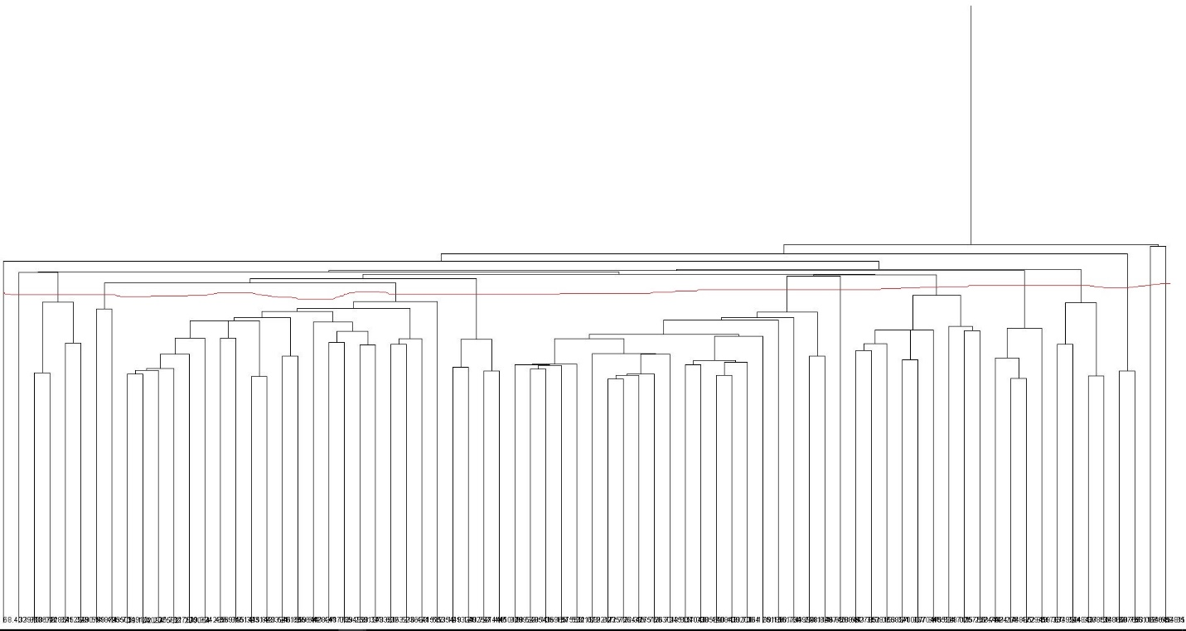

Data Set:

@RELATION relation

|  |  |
| --- | --- |
|  | @ATTRIBUTE 'name' {"100%_Bran","100%_Natural_Bran","All-Bran","All-Bran_with_Extra_Fiber","Almond_Delight","Apple_Cinnamon_Cheerios","Apple_Jacks","Basic_4","Bran_Chex","Bran_Flakes","Cap_primen_primeCrunch","Cheerios","Cinnamon_Toast_Crunch","Clusters","Cocoa_Puffs","Corn_Chex","Corn_Flakes","Corn_Pops","Count_Chocula","Cracklin_prime_Oat_Bran","Cream_of_Wheat_(Quick)","Crispix","Crispy_Wheat_&_Raisins","Double_Chex","Froot_Loops","Frosted_Flakes","Frosted_Mini-Wheats","Fruit_&_Fibre_Dates,_Walnuts,_and_Oats","Fruitful_Bran","Fruity_Pebbles","Golden_Crisp","Golden_Grahams","Grape-Nuts","Grape_Nuts_Flakes","Great_Grains_Pecan","Honey-comb","Honey_Graham_Ohs","Honey_Nut_Cheerios","Just_Right_Crunchy__Nuggets","Just_Right_Fruit_&_Nut","Kix","Life","Lucky_Charms","Maypo","Muesli_Raisins,_Dates,_&_Almonds","Muesli_Raisins,_Peaches,_&_Pecans","Mueslix_Crispy_Blend","Multi-Grain_Cheerios","Nut&Honey_Crunch","Nutri-Grain_Almond-Raisin","Nutri-grain_Wheat","Oatmeal_Raisin_Crisp","Post_Nat._Raisin_Bran","Product_19","Puffed_Rice","Puffed_Wheat","Quaker_Oat_Squares","Quaker_Oatmeal","Raisin_Bran","Raisin_Nut_Bran","Raisin_Squares","Rice_Chex","Rice_Krispies","Shredded_Wheat","Shredded_Wheat__primen_primeBran","Shredded_Wheat_spoon_size","Smacks","Special_K","Strawberry_Fruit_Wheats","Total_Corn_Flakes","Total_Raisin_Bran","Total_Whole_Grain","Triples","Trix","Wheat_Chex","Wheaties","Wheaties_Honey_Gold"} |
|  | @ATTRIBUTE 'mfr' {"A","G","K","N","P","Q","R"} |
|  | @ATTRIBUTE 'type' {"C","H"} |
|  | @ATTRIBUTE 'calories' numeric |
|  | @ATTRIBUTE 'protein' numeric |
|  | @ATTRIBUTE 'fat' numeric |
|  | @ATTRIBUTE 'sodium' numeric |
|  | @ATTRIBUTE 'fiber' numeric |
|  | @ATTRIBUTE 'carbo' numeric |
|  | @ATTRIBUTE 'sugars' numeric |
|  | @ATTRIBUTE 'potass' numeric |
|  | @ATTRIBUTE 'vitamins' numeric |
|  | @ATTRIBUTE 'shelf' numeric |
|  | @ATTRIBUTE 'weight' numeric |
|  | @ATTRIBUTE 'cups' numeric |
|  | @ATTRIBUTE 'rating' numeric |
|  | **@DATA**  **Cluster 1:**  **(Low Calorie, Medium Protein, Low Fat, Medium Sodium, Medium Fiber, Low Carbohydrte,Low Sugar,High Potassium, Low Vitamin, Medium Rating )**   |  |  |  |  |  |  |  |  |  |  |  |  | | --- | --- | --- | --- | --- | --- | --- | --- | --- | --- | --- | --- | | **Cereals** | **calories** | **protein** | **fat** | **sodium** | **fiber** | **carbo** | **sugars** | **potass** | **vitamins** | **shelf** | **rating** | | **100%_Bran** | **70** | **4** | **1** | **130** | **10** | **5** | **6** | **280** | **25** | **3** | **68.402973** |   **Cluster 2:**  **(Low Calorie, Medium Protein, Low Fat, High Sodium , Medium Fiber, Low Carbohydrte ,Low Sugar ,High Potassium,Low Vitamin, Low rating)**   |  |  |  |  |  |  |  |  |  |  |  |  | | --- | --- | --- | --- | --- | --- | --- | --- | --- | --- | --- | --- | | **Cereals** | **calories** | **protein** | **fat** | **sodium** | **fiber** | **carbo** | **sugars** | **potass** | **vitamins** | **shelf** | **rating** | | **All-Bran** | **70** | **4** | **1** | **260** | **9** | **7** | **5** | **320** | **25** | **3** | **59.42551** |   **Cluster 3 :**  **(Low Calorie ,Medium Protein, Zero Fat, Medium Sodium, High Fiber, Medium Carbohydrted ,No Sugar ,High Potassium, Low Vitamin,Medium rating)**   |  |  |  |  |  |  |  |  |  |  |  |  | | --- | --- | --- | --- | --- | --- | --- | --- | --- | --- | --- | --- | | **Cereals** | **calories** | **protein** | **fat** | **sodium** | **fiber** | **carbo** | **sugars** | **potass** | **vitamins** | **shelf** | **rating** | | **All-Bran_with_Extra_Fiber** | **50** | **4** | **0** | **140** | **14** | **8** | **0** | **330** | **25** | **3** | **93.704912** |   **Cluster 4:**  **(Medium Calorie ,Medium Protein, High Fat, Low Sodium, Low Fiber, Medium Carbohydrted ,Low Sugar ,Medium Potassium, Low Vitamin,Low rating)**   |  |  |  |  |  |  |  |  |  |  |  |  | | --- | --- | --- | --- | --- | --- | --- | --- | --- | --- | --- | --- | | **Cereals** | **calories** | **protein** | **fat** | **sodium** | **fiber** | **carbo** | **sugars** | **potass** | **vitamins** | **shelf** | **rating** | | **100%_Natural_Bran** | **120** | **3** | **5** | **15** | **2** | **8** | **8** | **135** | **0** | **3** | **33.983679** |   **Cluster 5:**  **(Low Fiber ,Low Potassium, Low Vitamin)**   |  |  |  |  |  |  |  |  |  |  |  |  | | --- | --- | --- | --- | --- | --- | --- | --- | --- | --- | --- | --- | | **Cereals** | **calories** | **protein** | **fat** | **sodium** | **fiber** | **carbo** | **sugars** | **potass** | **vitamins** | **shelf** | **rating** | | **Almond_Delight** | **110** | **2** | **2** | **2** | **200** | **1** | **14** | **8** | **25** | **3** | **34.384843** | | **Apple_Cinnamon_Cheerios** | **110** | **2** | **2** | **180** | **1.5** | **10.5** | **10** | **70** | **25** | **1** | **29.509541** | | **Basic_4** | **130** | **3** | **2** | **210** | **2** | **18** | **8** | **100** | **25** | **3** | **37.038562** | | **Cocoa_Puffs** | **110** | **1** | **1** | **180** | **0** | **12** | **13** | **55** | **25** | **2** | **22.736446** | | **Corn_Chex** | **110** | **2** | **0** | **280** | **0** | **22** | **3** | **25** | **25** | **1** | **41.445019** | | **Double_Chex** | **100** | **2** | **0** | **190** | **1** | **18** | **5** | **80** | **25** | **3** | **44.330856** | | **Great_Grains_Pecan** | **120** | **3** | **3** | **75** | **3** | **13** | **4** | **100** | **25** | **3** | **45.811716** | | **Honey_Graham_Ohs** | **120** | **1** | **2** | **220** | **1** | **12** | **11** | **45** | **25** | **2** | **21.871292** | | **"Muesli_Raisins,_Peaches,_&_Pecans"** | **150** | **4** | **3** | **150** | **3** | **16** | **11** | **170** | **25** | **3** | **34.139765** | | **Raisin_Nut_Bran** | **100** | **3** | **2** | **140** | **2.5** | **10.5** | **8** | **140** | **25** | **3** | **39.7034** | | **Raisin_Squares** | **90** | **2** | **0** | **0** | **2** | **15** | **6** | **110** | **25** | **3** | **55.333142** | | **Triples** | **110** | **2** | **1** | **250** | **0** | **21** | **3** | **60** | **25** | **3** | **39.106174** | | **Trix** | **110** | **1** | **1** | **140** | **0** | **13** | **12** | **25** | **25** | **2** | **27.753301** | | **Wheat_Chex** | **100** | **3** | **1** | **230** | **3** | **17** | **3** | **115** | **25** | **1** | **49.787445** |   **Cluster 6:**  **(Low Fat, Low fiber, Low Sugar,Low Potassium, Low Vitamin)**   |  |  |  |  |  |  |  |  |  |  |  |  | | --- | --- | --- | --- | --- | --- | --- | --- | --- | --- | --- | --- | | **Cereals** | **calories** | **protein** | **fat** | **sodium** | **fiber** | **carbo** | **sugars** | **potass** | **vitamins** | **shelf** | **rating** | | **Cocoa_Puffs** | **110** | **1** | **1** | **180** | **0** | **12** | **13** | **55** | **25** | **2** | **22.736446** | | **Corn_Chex** | **110** | **2** | **0** | **280** | **0** | **22** | **3** | **25** | **25** | **1** | **41.445019** | | **Raisin_Nut_Bran** | **100** | **3** | **2** | **140** | **2.5** | **10.5** | **8** | **140** | **25** | **3** | **39.7034** | | **Raisin_Squares** | **90** | **2** | **0** | **0** | **2** | **15** | **6** | **110** | **25** | **3** | **55.333142** |   **Cluster 7:**  **(Low Fat,High Potassium, Low Vitamin,Low rating)**   |  |  |  |  |  |  |  |  |  |  |  |  |  | | --- | --- | --- | --- | --- | --- | --- | --- | --- | --- | --- | --- | --- | | **Cereals** | **calories** |  | **protein** | **fat** | **sodium** | **fiber** | **carbo** | **sugars** | **potass** | **vitamins** | **shelf** | **rating** | | **Apple_Cinnamon_Cheerios** | **110** |  | **2** | **2** | **180** | **1.5** | **10.5** | **10** | **70** | **25** | **1** | **29.509541** | | **Bran_Flakes** | **90** |  | **3** | **0** | **210** | **5** | **13** | **5** | **190** | **25** | **3** | **53.313813** | | **Cheerios** | **110** |  | **6** | **2** | **290** | **2** | **17** | **1** | **105** | **25** | **1** | **50.764999** | | **Clusters** | **110** |  | **3** | **2** | **140** | **2** | **13** | **7** | **105** | **25** | **3** | **40.400208** | | **Corn_Flakes** | **100** |  | **2** | **0** | **290** | **1** | **21** | **2** | **35** | **25** | **1** | **45.863324** | | **Corn_Pops** | **110** |  | **1** | **0** | **90** | **1** | **13** | **12** | **20** | **25** | **2** | **35.782791** | | **Crispy_Wheat_&_Raisins** | **100** |  | **2** | **1** | **140** | **2** | **11** | **10** | **120** | **25** | **3** | **36.176196** | | **"Fruit_&_Fibre_Dates,_Walnuts,_and_Oats"** | **120** |  | **3** | **2** | **160** | **5** | **12** | **10** | **200** | **25** | **3** | **40.917047** | | **Fruity_Pebbles** | **110** |  | **1** | **1** | **135** | **0** | **13** | **12** | **25** | **25** | **2** | **28.025765** | | **Grape-Nuts** | **110** |  | **3** | **0** | **170** | **3** | **17** | **3** | **90** | **25** | **3** | **53.371007** | | **Kix** | **110** |  | **2** | **1** | **260** | **0** | **21** | **3** | **40** | **25** | **2** | **39.241114** | | **Mueslix_Crispy_Blend** | **160** |  | **3** | **2** | **150** | **3** | **17** | **13** | **160** | **25** | **3** | **30.313351** | | **Shredded_Wheat_'n'Bran** | **90** |  | **3** | **0** | **0** | **4** | **19** | **0** | **140** | **0** | **1** | **74.472949** | | **Total_Whole_Grain** | **100** |  | **3** | **1** | **200** | **3** | **16** | **3** | **110** | **100** | **3** | **46.658844** |   **Cluster 8:**  **(Medium Calorie ,Medium Protein, Low Fat, Low Fiber, Medium Carbohydrted ,Low Potassium, Low Vitamin,Medium rating)**   |  |  |  |  |  |  |  |  |  |  |  |  | | --- | --- | --- | --- | --- | --- | --- | --- | --- | --- | --- | --- | | **Cereals** | **calories** | **protein** | **fat** | **sodium** | **fiber** | **carbo** | **sugars** | **potass** | **vitamins** | **shelf** | **rating** | | **Apple_Jacks** | **110** | **2** | **0** | **125** | **1** | **11** | **14** | **30** | **25** | **2** | **33.174094** | | **Cinnamon_Toast_Crunch** | **120** | **1** | **3** | **210** | **0** | **13** | **9** | **45** | **25** | **2** | **19.823573** | | **Count_Chocula** | **110** | **1** | **1** | **180** | **0** | **12** | **13** | **65** | **25** | **2** | **22.396513** | | **Cracklin'_Oat_Bran** | **110** | **3** | **3** | **140** | **4** | **10** | **7** | **160** | **25** | **3** | **40.448772** | | **Cream_of_Wheat_(Quick)** | **100** | **3** | **0** | **80** | **1** | **21** | **0** | **0** | **2** |  | **64.533816** | | **Crispix** | **110** | **2** | **0** | **220** | **1** | **21** | **3** | **30** | **25** | **3** | **46.895644** | | **Frosted_Flakes** | **110** | **1** | **0** | **200** | **1** | **14** | **11** | **25** | **25** | **1** | **31.435973** | | **Frosted_Mini-Wheats** | **100** | **3** | **0** | **0** | **3** | **14** | **7** | **100** | **25** | **2** | **58.345141** | | **Golden_Crisp** | **100** | **2** | **0** | **45** | **0** | **11** | **15** | **40** | **25** | **1** | **35.252444** | | **Golden_Grahams** | **110** | **1** | **1** | **280** | **0** | **15** | **9** | **45** | **25** | **2** | **23.804043** | | **Grape_Nuts_Flakes** | **100** | **3** | **1** | **140** | **3** | **15** | **5** | **85** | **25** | **3** | **52.076897** | | **Lucky_Charms** | **110** | **2** | **1** | **180** | **0** | **12** | **12** | **55** | **25** | **2** | **26.734515** | | **Maypo** | **100** | **4** | **1** | **0** | **0** | **16** | **3** | **95** | **25** | **2** | **54.850917** | | **"Muesli_Raisins,_Dates,_&_Almonds"** | **150** | **4** | **3** | **95** | **3** | **16** | **11** | **170** | **25** | **3** | **37.136863** | | **Multi-Grain_Cheerios** | **100** | **2** | **1** | **220** | **2** | **15** | **6** | **90** | **25** | **1** | **40.105965** | | **Nut&Honey_Crunch** | **120** | **2** | **1** | **190** | **0** | **15** | **9** | **40** | **25** | **2** | **29.924285** | | **Total_Raisin_Bran** | **140** | **3** | **1** | **190** | **4** | **15** | **14** | **230** | **100** | **3** | **28.592785** |   **Cluster 9:**  **(Low Calorie ,Medium Protein, Low Fat, Medium Sodium, Low Fiber, Medium Carbohydrted ,Medium Potassium, Low Vitamin,Medium rating)**   |  |  |  |  |  |  |  |  |  |  |  |  | | --- | --- | --- | --- | --- | --- | --- | --- | --- | --- | --- | --- | | **Cereals** | **calories** | **protein** | **fat** | **sodium** | **fiber** | **carbo** | **sugars** | **potass** | **vitamins** | **shelf** | **rating** | | **Bran_Chex** | **90** | **2** | **1** | **200** | **4** | **15** | **6** | **125** | **25** | **1** | **49.12025** |   **Cluster 10:**  **(Medium Calorie ,Medium Protein, Low Fat, Medium Sodium, Low Fiber, Medium Carbohydrted ,Low Sugar ,Low Potassium, Low Vitamin,Medium rating)**   |  |  |  |  |  |  |  |  |  |  |  |  | | --- | --- | --- | --- | --- | --- | --- | --- | --- | --- | --- | --- | | **Cereals** | **calories** | **protein** | **fat** | **sodium** | **fiber** | **carbo** | **sugars** | **potass** | **vitamins** | **shelf** | **rating** | | **Just_Right_Crunchy__Nuggets** | **110** | **2** | **1** | **170** | **1** | **17** | **6** | **60** | **100** | **3** | **36.523683** |   **Cluster 11:**  **(High Calorie, High Protein ,Medium Fat, High Sodium, Low fiber, High Carbohydrte , Low Sugar, Low Potassium)**   |  |  |  |  |  |  |  |  |  |  |  |  | | --- | --- | --- | --- | --- | --- | --- | --- | --- | --- | --- | --- | | **Cereals** | **calories** | **protein** | **fat** | **sodium** | **fiber** | **carbo** | **sugars** | **potass** | **vitamins** | **shelf** | **rating** | | **Quaker_Oat_Squares** | **100** | **4** | **1** | **135** | **2** | **14** | **6** | **110** | **25** | **3** | **49.511874** |   **Cluster 12:**  **(Medium Calorie ,Low Protein, Low Fat, Low Sodium, Low Fiber, Medium Carbohydrted ,High Sugar ,LowPotassium, Low Vitamin,Low rating)**   |  |  |  |  |  |  |  |  |  |  |  |  | | --- | --- | --- | --- | --- | --- | --- | --- | --- | --- | --- | --- | | **Cereals** | **calories** | **protein** | **fat** | **sodium** | **fiber** | **carbo** | **sugars** | **potass** | **vitamins** | **shelf** | **rating** | | **Froot_Loops** | **110** | **2** | **1** | **125** | **1** | **11** | **13** | **30** | **25** | **2** | **32.207582** | | **Smacks** | **110** | **2** | **1** | **70** | **1** | **9** | **15** | **40** | **25** | **2** | **31.230054** |   **Cluster 13:**  **(Low Calorie ,Medium Protein, Zero Fat, Medium Sodium, High Fiber, Medium Carbohydrted ,No Sugar ,High Potassium, Low Vitamin,Low rating)**   |  |  |  |  |  |  |  |  |  |  |  |  | | --- | --- | --- | --- | --- | --- | --- | --- | --- | --- | --- | --- | | **Cereals** | **calories** | **protein** | **fat** | **sodium** | **fiber** | **carbo** | **sugars** | **potass** | **vitamins** | **shelf** | **rating** | | **Life** | **100** | **4** | **2** | **150** | **2** | **12** | **6** | **95** | **25** | **2** | **45.328074** |   **Cluster 14:**  **(Medium Calorie ,Medium Protein,Low Fat, High Sodium, Medium Fiber, High Potassium, Low Vitamin,Low rating)**   |  |  |  |  |  |  |  |  |  |  |  |  | | --- | --- | --- | --- | --- | --- | --- | --- | --- | --- | --- | --- | | **Cereals** | **calories** | **protein** | **fat** | **sodium** | **fiber** | **carbo** | **sugars** | **potass** | **vitamins** | **shelf** | **rating** | | **Raisin_Bran** | **120** | **3** | **1** | **210** | **5** | **14** | **12** | **240** | **25** | **2** | **39.2592** | |

**Hierarchical cluster tree with cutting point without Vitamin Data:**

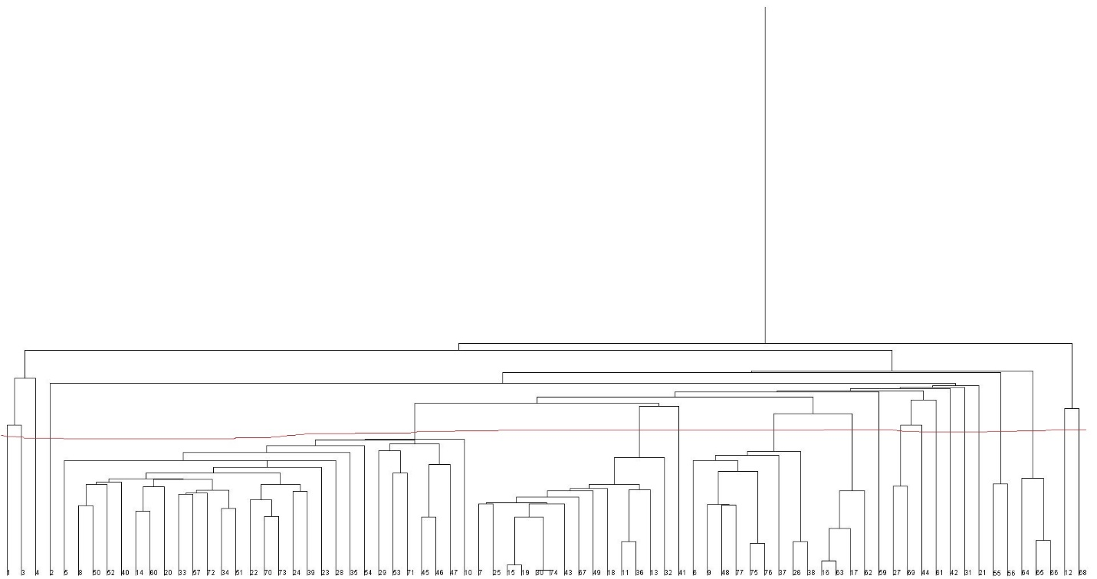

**There is 20 cluster.**

**Questions:**

**1.** Question: Is a strong correlation between dietary fiber and potassium?

Answer: Yes, there is a strong correlation between dietary fiber and potassium. That is because the correlation of the fiber is proportional to potassium. We can also see from the plot area in the graph which is given below that the position of dietary fiber and potassium increased linearly or proportionally.

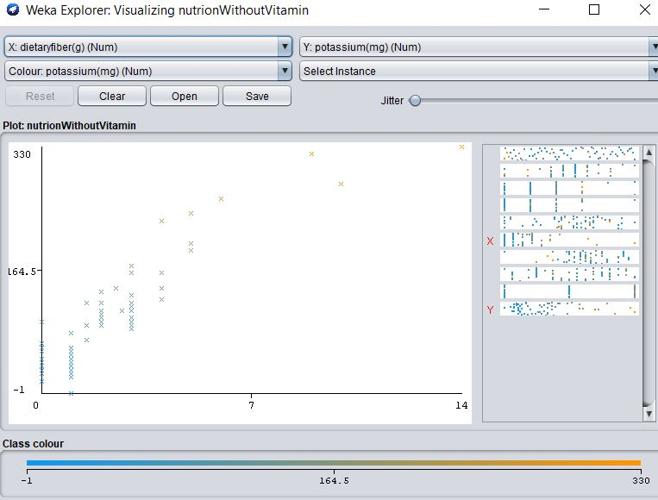

**2.** Question: Are groups of cereals from which we can choose according to our preferences?

Answer: Yes, from the 14 clusters anyone can get any combination of he/she likes such as-

1) People who want low calorie and no fat and no sugar can choose cluster 13.

2) People can take high potassium and high fiber one can have better cereals on cluster 3 & 13.

3) ) People who want high calories and protein with low sugar can pick a cereal from cluster 11.

3. Question: See other correlation between the data given in the files.

Answer:

-Sodium and Fat co relation

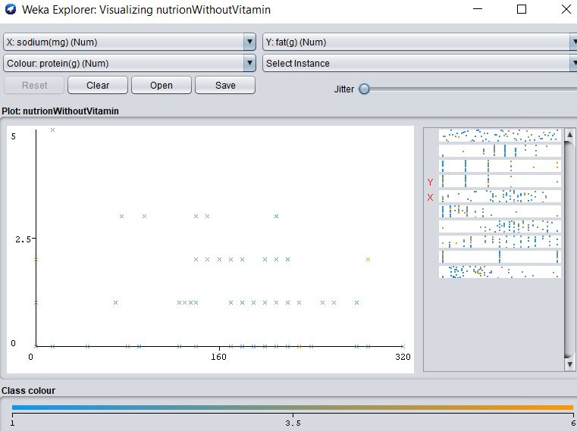

--Calorie and Sugar co-relation

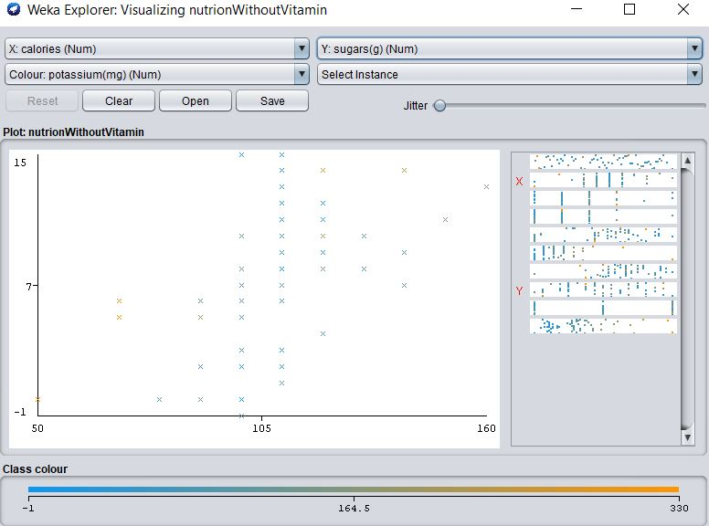

-- Fiber and Carbohydrte co-relation

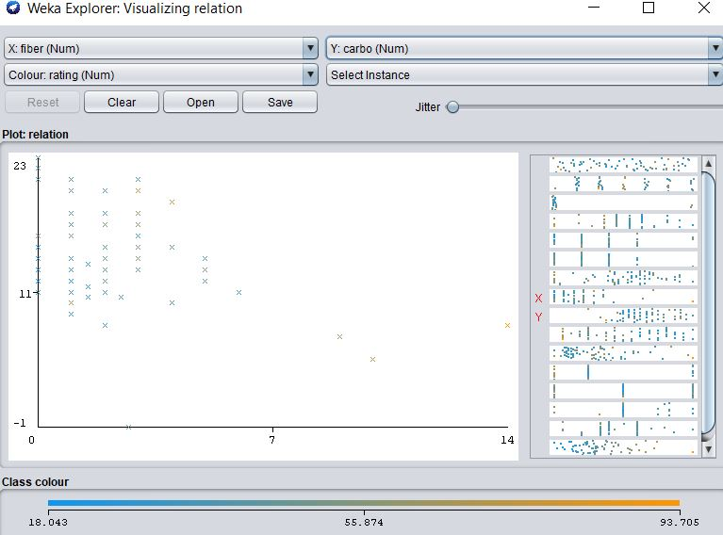

--protein and sugar co relation:

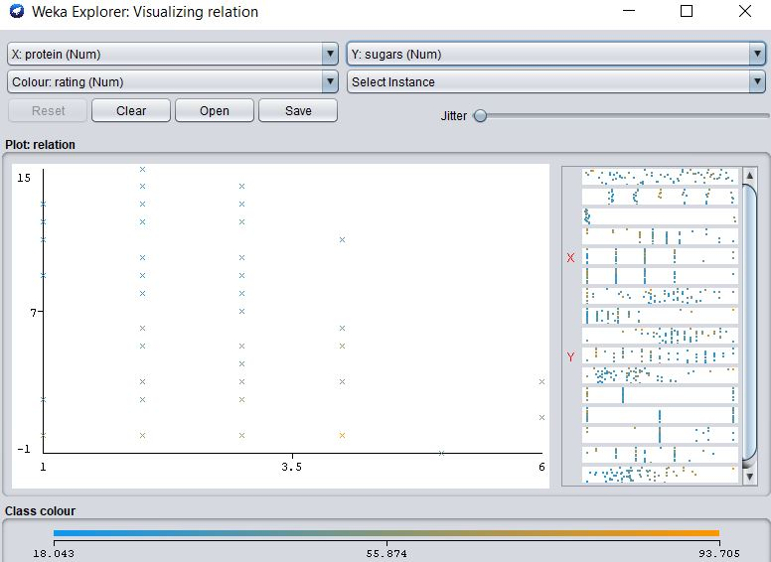

Question 4: Try to find some other information

Answer:

In our given dataset, we also find that where calorie is more there is less protein. And where is more calorie.

Let’s we take 100_Natural_Bran where the calorie level is 120g and protein is 3g. There is invert relation between them.